User manual

Ant simulation

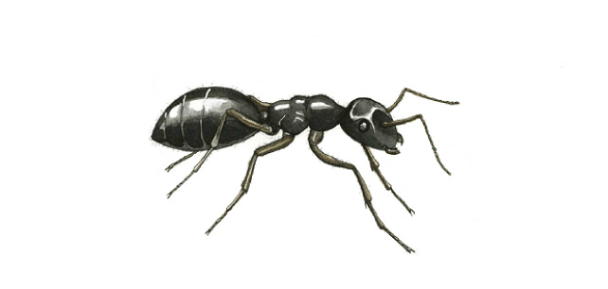

Table of Contents

Introduction 2

Simulation overview 3

Installation 5

Layout 6

Use 7

Features 14

Errors 14

# Introduction

The tool is aimed at student’s studying evolution and natural selection in biology. It is primarily an ant simulation which can be used to see concepts such as survival of the fittest, inheritance, mutation and a number of other ideas around evolution. The tool allows the user to interact with the simulation by the altering of ant species characteristics. This allows the user to design ants and see how they evolve over time, (or die off by getting out competed by better adapted ants). Ants compete for food which is placed randomly on the map. The best adapted ants will be able to collect more food than other ants and so will be able to survive for longer. The tool is a web application and can therefore be accessed within the classroom as well as at home with just a web browser.

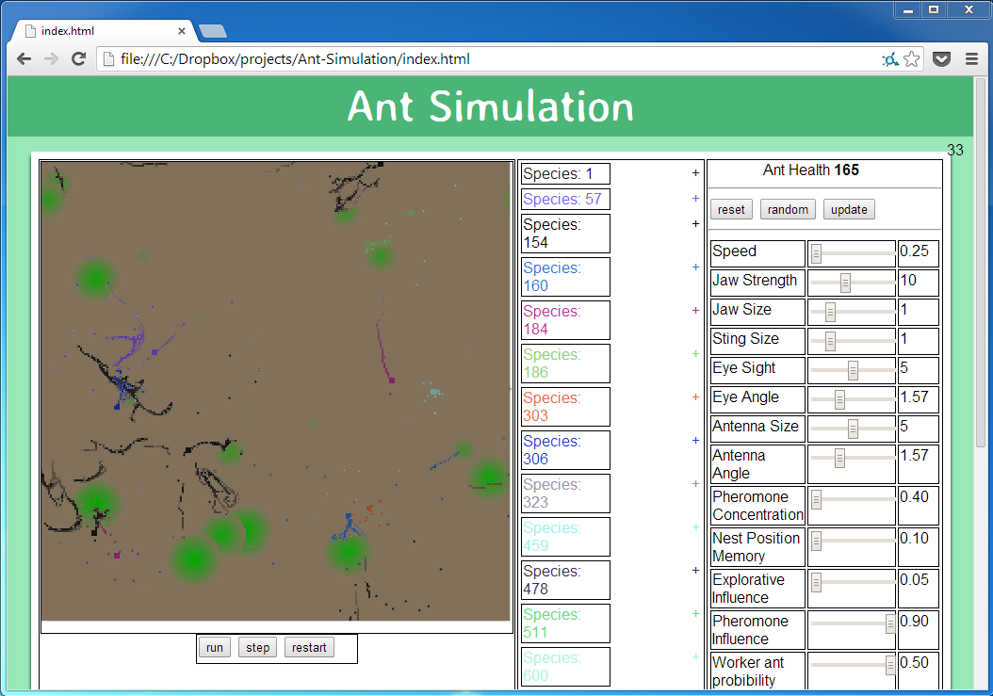

# Simulation overview

This tool simulates how ant’s characteristics affect behaviour and effectiveness of survival. It models three types of ants:

* **Worker ants** – Responsible for finding, collecting and depositing food to the nest.
* **Soldier ants** – Responsible for guarding ants of the same species and also attacking ants and nests from other species.
* **Queen ants** – Responsible for locating a site to create a nest, and then creating a nest.

**C:\Dropbox\projects\Ant-Simulation\assests\User Manual\Ants\Queen ant.PNGC:\Dropbox\projects\Ant-Simulation\assests\User Manual\Ants\Soldier ant.PNGC:\Dropbox\projects\Ant-Simulation\assests\User Manual\Ants\Worker ant (food).PNGC:\Dropbox\projects\Ant-Simulation\assests\User Manual\Ants\Worker ant (no food).PNG***From left to right – A worker ant, a worker ant carrying food, a soldier ant and a queen ant*

The simulation revolves around the ants struggle for food. Food is represented by green blobs. Food is slowly taken away from its original position by worker ants and deposited to the nest. The food is used for creating more ants as well as maintaining the current ants. The darker the colour of the food the more food is concentrated.

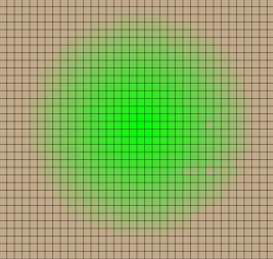

A blob of food

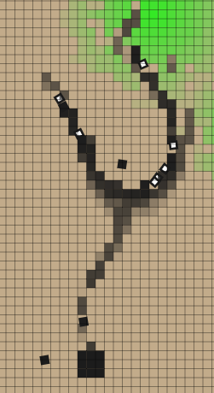

A pheromone trial from food to the nest. It is being followed by a number of ants so returning with food and others looking for food.

Ant nests are the birth place of all ants. If a nest has excess food i.e. more than enough for it to survive itself, a new ant can be born. The amount of food an ant costs is controlled by the ant’s species. The more food the ant costs, the longer it can survive for after it is born. Ants born from a particular nest remain loyal to that nest e.g. a worker born from a particular nest will only deposit food to that nest.

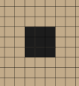

An ant nest

Pheromones are chemical trials deposited by worker ants returning with food back to the nest. They are used by ants who are looking for food, as they should lead to either a source of food or the nest. The stronger a pheromone trial is (the darker its colour) the more likely an ant will follow it. Over time the pheromones concentration will decrease as they evaporate.

Characteristics are features of ants which change their behaviour e.g. the speed characteristic alters how fast an ant can move in the simulation, this is an advantage as it allows the ant to more quickly search for food. However favourable characteristics come at a cost, the more useful a characteristic is the more food is lost in the creation of the ant. So a balance is required to find the most efficient or largest growing population of ants. The characteristics which can be changed are:

* **Speed** - The speed that an ant can move.
* **Jaw Strength** – The strength of the ants jaw (determines how much food the ant can carry).
* **Jaw Size** – The amount of damage a soldier ant can inflict.
* **Sting Size** – The range which a soldier ant can attack.
* **Eyesight –** The range an ant can see.
* **Eye Angle –** The angle through which the ant can see.
* **Antenna Size –** The angle through which an ant can detect pheromones.
* **Pheromone Concentration –** The concentration of pheromones an ant can secrete.
* **Nest Position Memory –** A measure of how well an ant knows where its nest is.
* **Explorative Influence** – The likelihood of an ant changing its direction e.g. not following pheromones.
* **Pheromone Influence** – The likelihood of an ant following a pheromone trial.
* **Worker ant probability** – The probability of a worker ant being born compared with other types of ants.
* **Worker ant food cost** – The amount of food required to create a worker ant (the more health the ant starts with the longer the ant can live before it needs to eat again).
* **Soldier ant probability** – The probability of a soldier ant being born compared with other types of ants.
* **Soldier ant food cost** – The amount of food required to create a soldier ant (the more health the ant starts with the longer the ant can live before it needs to eat again).
* **Queen ant probability** – The probability of a queen ant being born compared with other types of ants.
* **Queen ant food cost** – The amount of food required to create a queen ant (the more health the ant starts with the longer the ant can live before it needs to eat again).
* **Minimum number of Queen steps** – The minimum number of steps a queen will take before reaching its nest site.
* **Maximum number of Queen steps** – The maximum number of steps a queen will take before reaching its nest site.
* 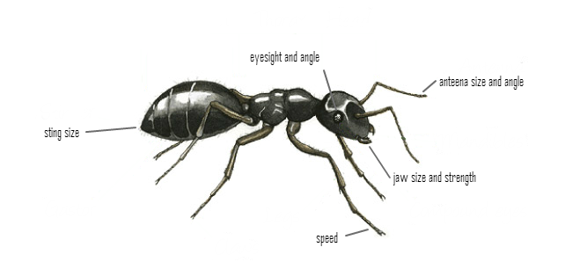**Reproduction rate** – The chance of a new ant being born.

A species is a specific set of values for an ants characteristics. All ants belong to a single species in the simulation. A species values for characteristics can be edited through the interface (see layout) however the characteristics of a species have a chance of mutating in the simulation whenever a queen ant is born. If the species does not mutate, the queen will go on to create a nest expanding the spread of the species. However, if a mutation does occur a new species is created and all ants born from the nest which the queen founds will inherit the mutated characteristic. This can be either an advantage or disadvantage on the efficiency of the ant.

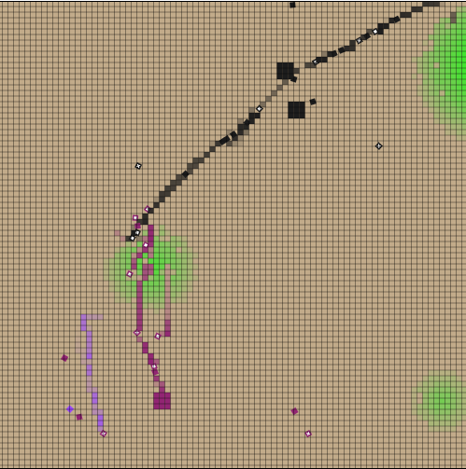

Three different species shown, including 3 nests (two of the same species)

# Installation

There is no need to install the simulation, it can be run via visiting it in a web browser.

## System Requirements

|  |  |  |
| --- | --- | --- |
| **Web browser** | **Minimum required** | **Recommended version** |
| Chrome | 4 | 30 or higher |
| Firefox | 4 | 25 or higher |
| Internet Explorer | 10 | 11 or higher |
| Safari | 3.1 | 7.0 or higher |

# Layout

The page is split into three sections, the simulation panel, data panel and configuration panel.

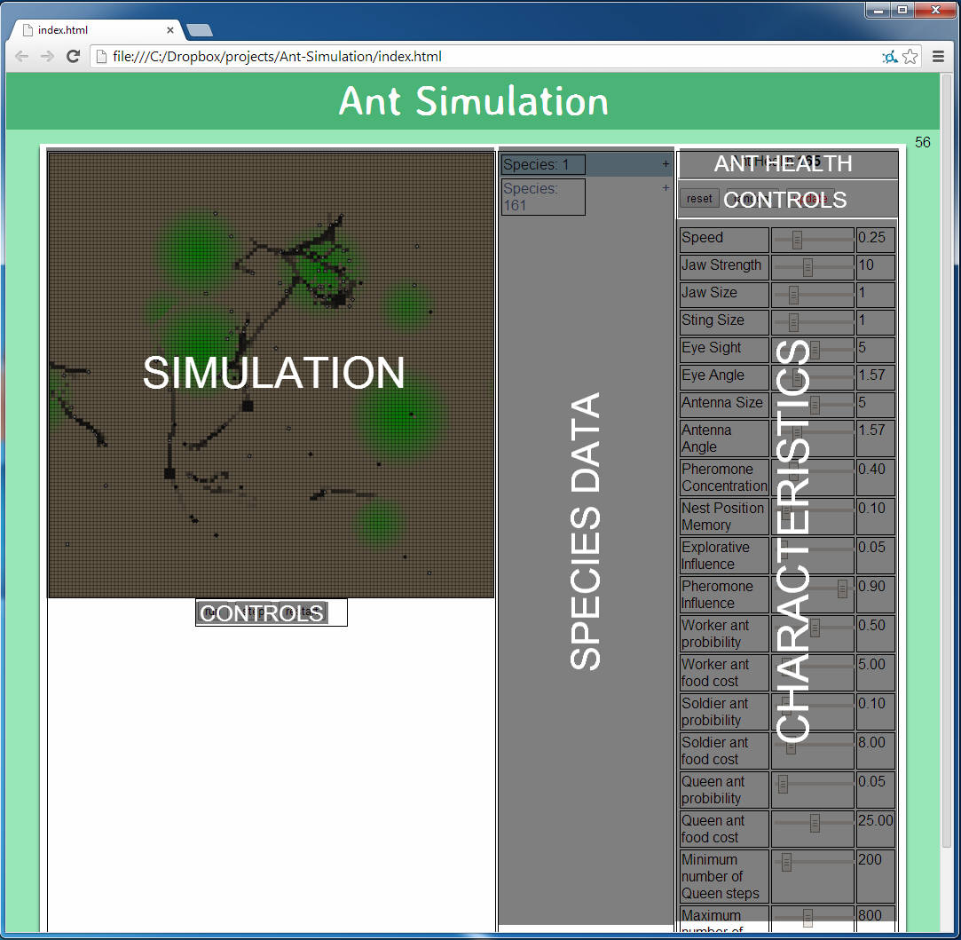

## Simulation panel

Contains the simulation itself, as well as three buttons which are used to control the simulation:

* C:\Dropbox\projects\Ant-Simulation\assests\User Manual\Uses\Time controls.PNG**Run/Pause** – Toggle to start and stop the simulation
* **Tick** – Move a single step forward in the simulation. Useful if you want to closely observe the ant’s behaviour.
* **Restart** – Reset the simulation to default settings.

## Data panel

The data panel contains information about all of the species currently in the simulation. As new species are created i.e. mutations occur, they are added to the data panel. Each species can be expanded by clicking on the +/- button to show more information about that species such as the number of ants and nests and the amount of food in the nests. The colour of the species text is the same colour of the species which it represents. You can select a species by clicking on the species name, this will move the simulation to centre on the first nest in the species, it will also display the species characteristics in the configuration panel. (Note: the numbers next to the species id the species ID, it does not represent any information about the species i.e. Species: 17.)

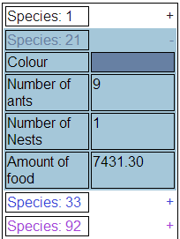

Species 21 is expanded and selected

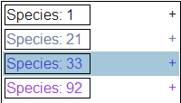

The specie panel, all species are contracted. Species: 33 is selected

## Configuration panel

C:\Dropbox\projects\Ant-Simulation\assests\User Manual\Uses\configuration panel controls.PNGThe configuration panel contains the characteristics of the selected species. By changing the inputs, characteristics values can be altered. Once a modification to a characteristic is made the ants health is updated to reflect this change. The buttons at the top control the inputs:

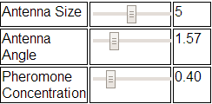

A sample of characteristics

* **Reset** – Resets all characteristics to their default values.
* **Random** – Replaces all characteristics with random values.
* **Update** – Updates the selected species to reflect the changes made in the characteristics panel.

# Use

## How to change characteristics?

To change a characteristic for a particular species:

### **1** – Select the species

This is done by clicking on the species in the data panel. It will bring up the selected species characteristics in the species panel.

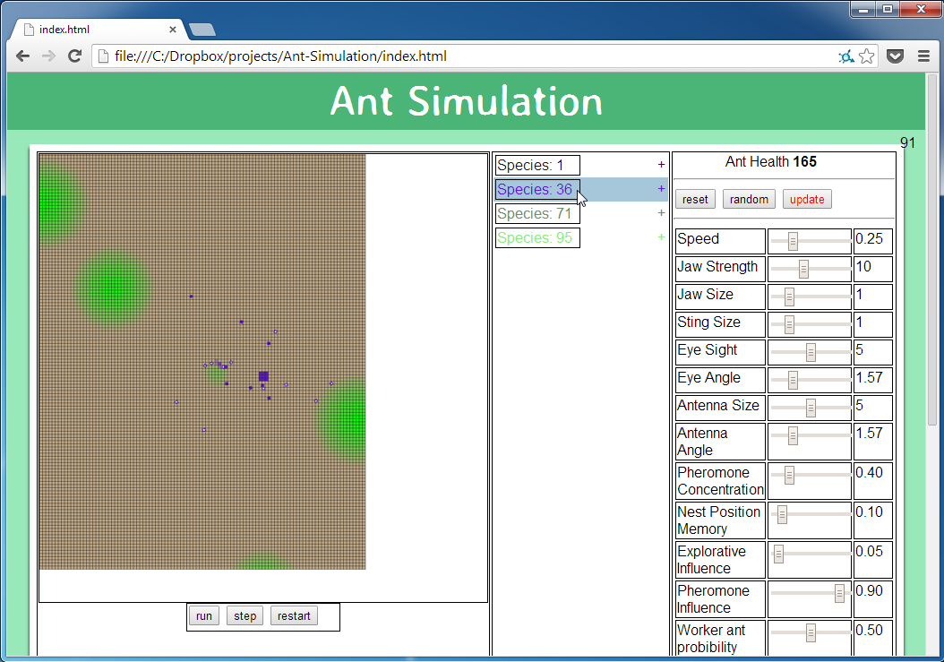

Selecting species 36

### **2** – Choose characteristic to change

In the characteristics panel, click on the characteristic you want to change

Note: Hovering over the characteristic will give you a description of what the characteristic does.

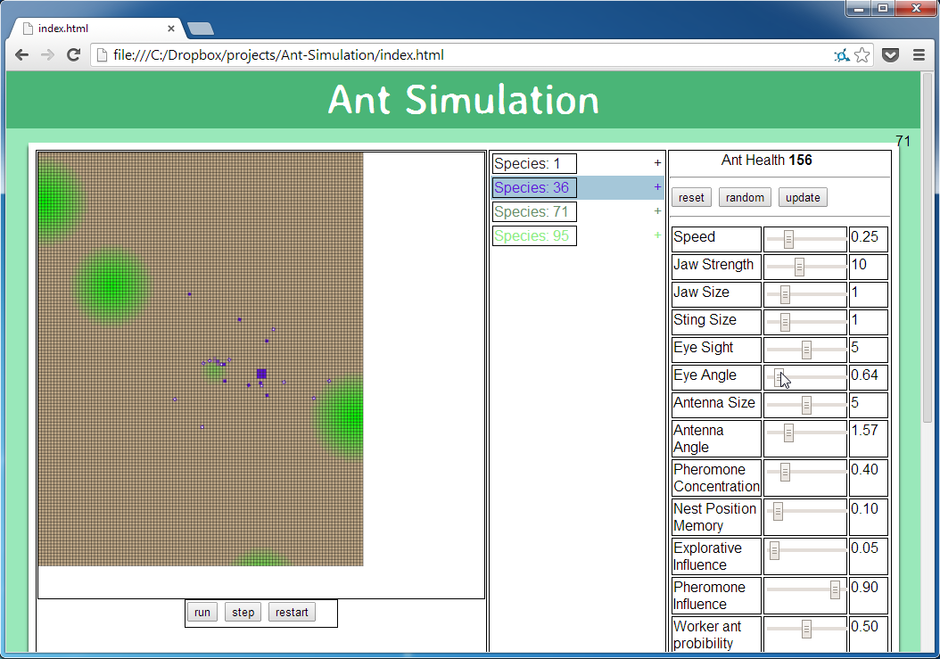

Changing the eye angle characteristic

### **3** – Change the characteristic

To change the characteristic move the slider left or right, the value can be seen to the right of the slider for comparison.

Note: This will also change the Ant health and it will change the colour of the update button

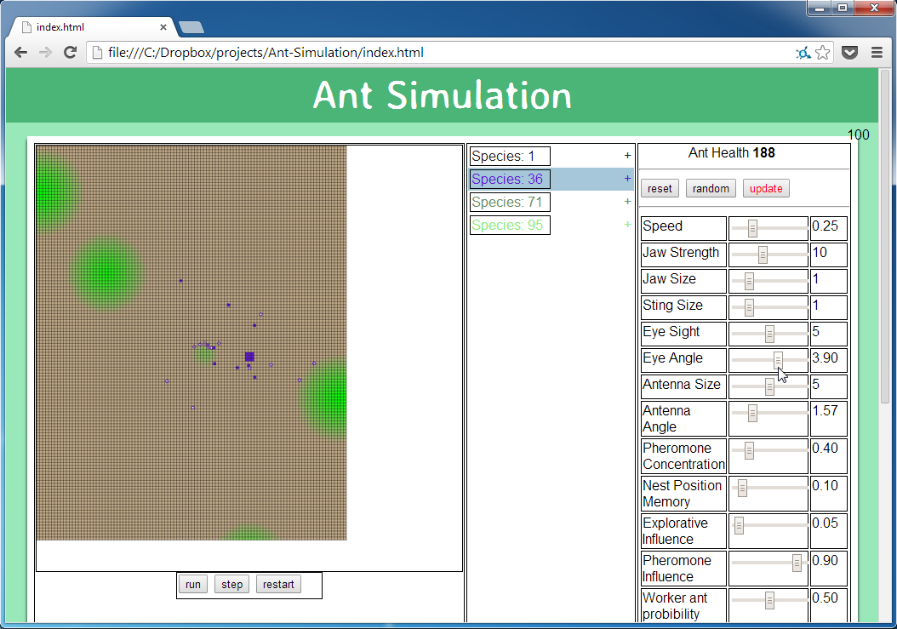

Changing the characteristic for eye angle

### **4** – Update

To update the species in the simulation click the update button.

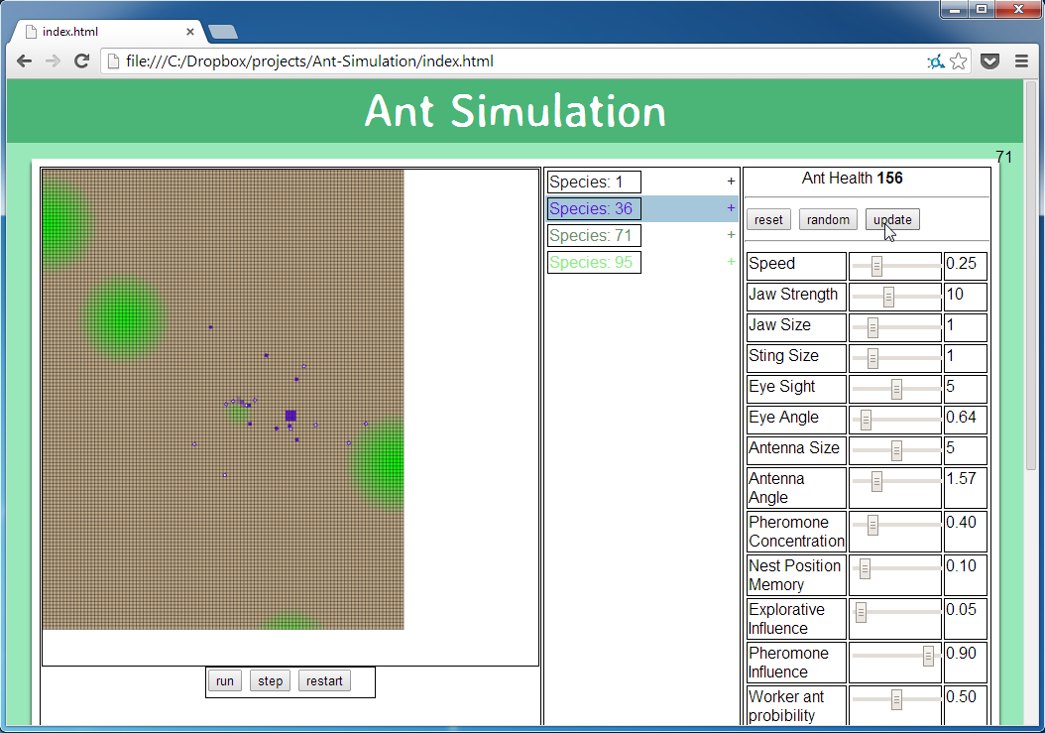

Pressing the update button

Note: This will change the update button back to its normal colour.

## How to move around the map?

### **1** – Place cursor over the simulation

Place your cursor anyway over the simulation. The pointer will change to a navigation pointer.

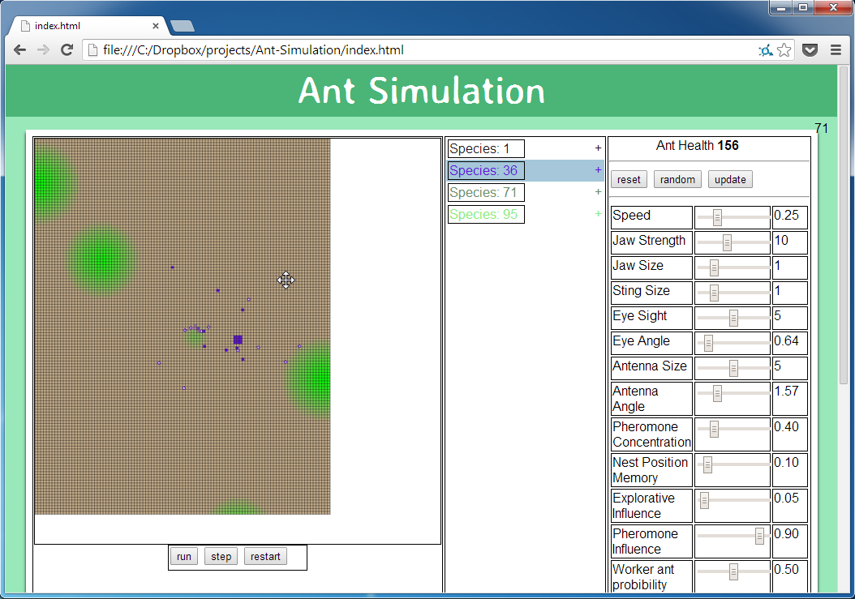

### **2** – Click and drag the cursor

Click and move the mouse, the simulation will follow your mouse.

Note: The arrow keys can also be used to move around the map.

## C:\Dropbox\projects\Ant-Simulation\assests\User Manual\Uses\pan\2 - Click and drag.png

## How to zoom in and out?

### **1** – Place cursor over the simulation

Place your cursor anyway over the simulation. The pointer will change to a navigation pointer.

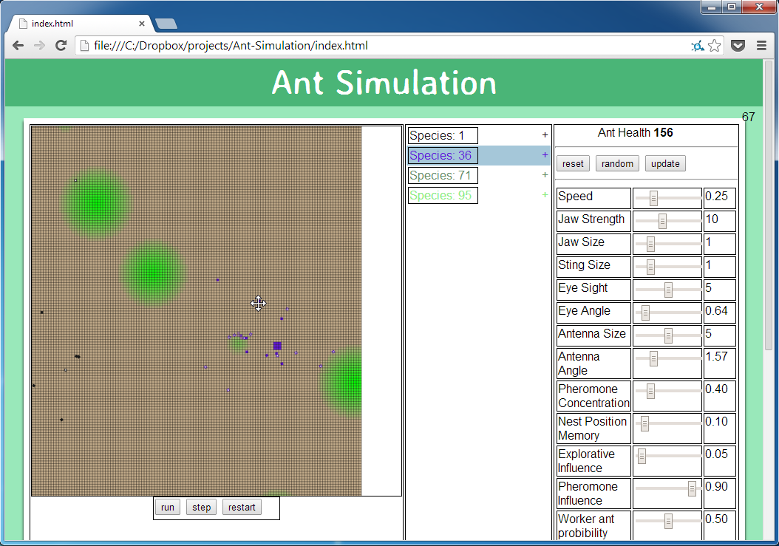

### **2** – Scroll

Use the mouse scroll wheel up or down to zoom the map in and out respectfully.

Note: The + and - keys can also be used to zoom in and out.

## C:\Dropbox\projects\Ant-Simulation\assests\User Manual\Uses\zoom\2 - Scroll.png

## Tips and shortcuts

|  |  |
| --- | --- |
| **Control** | **Action** |
| Arrow keys | Pan around the map |
| Mouse click and drag | Pan around the map |
| + and - keys | Zoom into and out of the map |
| Mouse scroll | Zoom into and out of the map |
| Space key | Pause/Play the simulation |
| R key | Restart the simulation |
| S key | Do a single step in the simulation |

* 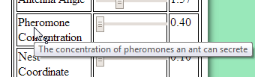Hovering over a characteristic will display a description of what it does.
* Clicking on a species will centre the map on the first nest in that species.
* C:\Dropbox\projects\Ant-Simulation\assests\User Manual\Uses\configuration panel controls (update).PNGThe update button will turn red if there is a change to the configuration of a species characteristics which is not reflected in the simulation.

# Features

# Errors

## Warning #1 – Species cost greater than workers food cost

### Problem

### C:\Dropbox\projects\Ant-Simulation\assests\User Manual\Errors\Warning #1.png

The warning is encounter when a species worker ant food cost is lower the ant health. This would cause worker ants to die immediately as they are born.

### Recovery

To recover try either:

* Lowering the species characteristics until ant health is below the worker food cost.
* Raising the worker food cost until it is greater than the ant health.

## Warning #2 – Species cost greater than queen food cost

### Problem

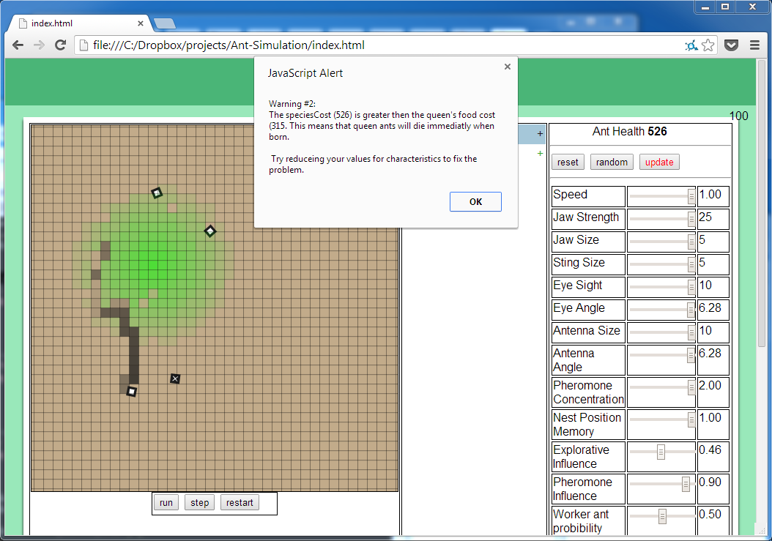

The warning is encounter when a species queen ant food cost is lower the ant health. This would cause queen ants to die immediately as they are born.

### Recovery

To recover try either:

* Lowering the species characteristics until ant health is below the queen food cost.
* Raising the queen food cost until it is greater than the ant health.

## Warning #3 – Species cost greater than soldier food cost

### Problem

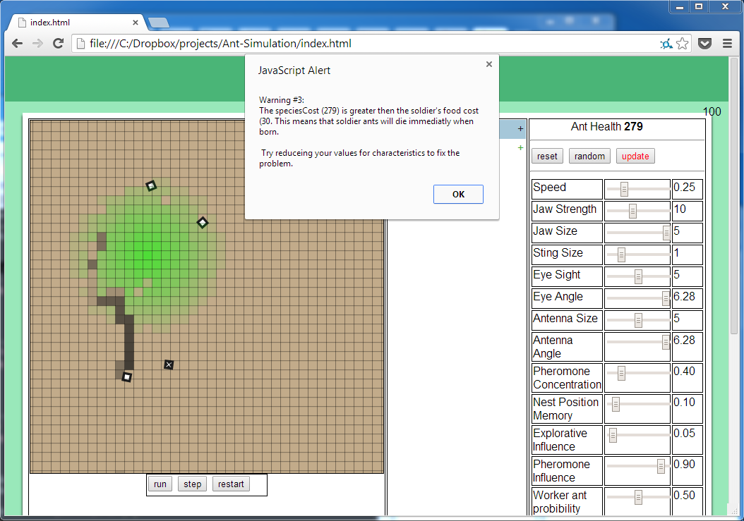

The warning is encounter when a species soldier ant food cost is lower the ant health. This would cause soldier ants to die immediately as they are born.

### Recovery

To recover try either:

* Lowering the species characteristics until ant health is below the soldier food cost.
* Raising the soldier food cost until it is greater than the ant health.

## Error #1 – Minimum number of queen steps greater than maximum

### Problem

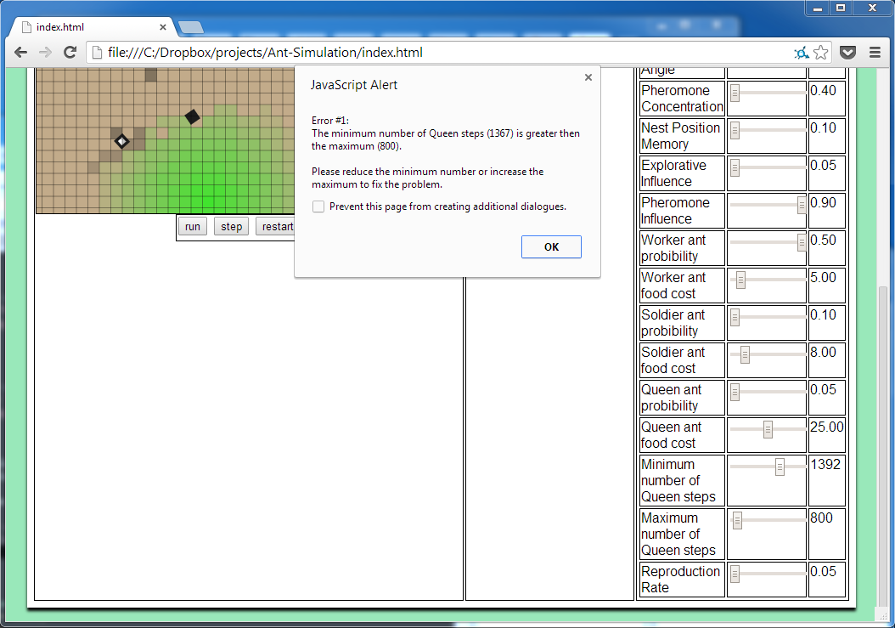

The error is caused when a species minimum number of queen steps is greater than the maximum number of queen steps. This would cause queens to create nests as soon as they were born rather than moving away from the nest.

### Recovery

To recover from this error try:

* Lowering the minimum number of queen steps until it is below the maximum number of queen steps.
* Raising the maximum number of queen steps until it is greater then the minimum number of queen steps.

## No ants are left

### Problem

This is caused when all ants and nests have died off.

### Recovery

The simulation must be restarted. This can be done by clicking the restart button in the simulation controls or by refreshing the page.

## Too many species

### Problem

This happens when there are many unique species in the simulation and they are all shown in the data panel.

### Recovery

Suggestions to fix or reduce problem:

* Reduce the queen probability, this will reduce the number of queens produced and therefore reduce the amount of new species.
* Minimise any opened data on species.
* Restart the simulation.

## The simulation is slow

### Problem

The problem is caused if too many ants are in the simulation. This often happens when the simulation is run for extended amounts of time.

### Recovery

To reduce the problem try:

* Lowering the worker probability, queen probability and soldier probability characteristics. This will slow the creation of ants in the simulation allowing it to be run for longer periods of time.
* Lowering the eye sight or antenna size characteristics. This will allow the simulation to run faster and handle more ants.
* Lowering the pheromone concentration. This will allow the simulation to run faster as there will be fewer pheromones in the simulation.
* Lowering the reproduction rate. This will reduce the number of ants born. Allowing the simulation to run faster.
* Running the simulation on a faster computer.

## Only one species

### Problem

The problem is caused if new species are not being created. This happens if queen ants are not being born, or new species nests die quickly after they are created.

### Recovery

To fix this problem try:

* Increase the reproduction rate. This will allow more ants to be born, increasing the chance of a queen ant being born.
* Increase the queen ant probability. This will cause more queen ants to be born.
* Increase the queen food cost. This will allow other species nests to survive for longer and potentially become successful.
* Design a species to survive for longer by editing the characteristics (try resetting the characteristics by pressing the reset button in the characteristics controls).

## Ants not moving

### Problem

If ants have a very low speed they will appear not to move

### Recovery

Increase the speed characteristic of the species.